**AT_GRASP**

Creating Eclipse luna build environment for windows

Eclipse + CDT + Cygwin + MinGW

**Requirements:**

* This is configured under Eclipse LUNA with CDT: download Eclipse with C++
* Source code AT_GRASP
* Compiled shared/static libraries and include header files of BCP 1.1.3 (See Compiling BCP-1.1.3 for creating libraries under windows) inside source code directory tree
* Optional Libraries inside AT_GRASP source tree
* MinGW for windows (latest)
* Cygwin with:
  + GCC 4.9.2
* lapack,blas,quadmath,frontran,libraries
* Cygwin shared libraries (DLL) With build folder inside source code directory tree with this files: (can be located from cygwin installation directory <cygwin dir>/bin, <cygwin dir>/lib )

cygwin1.dll, cygstdc++-6.dll,cygquadmath-0.dll, cyggfortran-3.dll, cyggcc_s-1.dll,cyglapack-0.dll

cygblas-0.dll, cyggccpp-1.dll

* Using Work space indicated in eclipse

1. **Import AT_GRASP source to eclipse:**

file->new->Make Project with Existing code

locate source code of project. Name the project and select Cygwin GCC for tool chain.

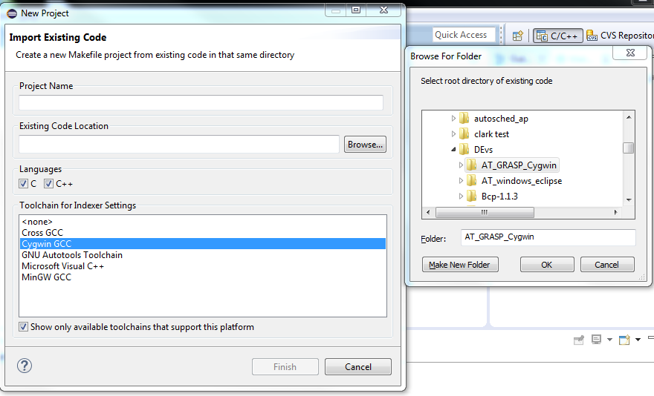

1. **Setting up Build environment:**
2. **Build Variables:**

Configure Mingw make file.

Go to project properties -> C/C++ Build -> Build Variables.

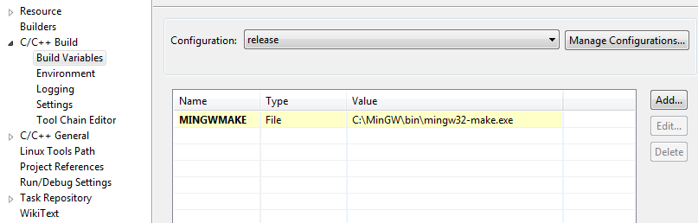

Add a variable.

**Variable Name** = MINGWMAKE or any you like. This will be used as a reference for the location of make file.

**Check apply to all configuration**

**Type**: file

**Value**: browse the location of mingw32-make.exe

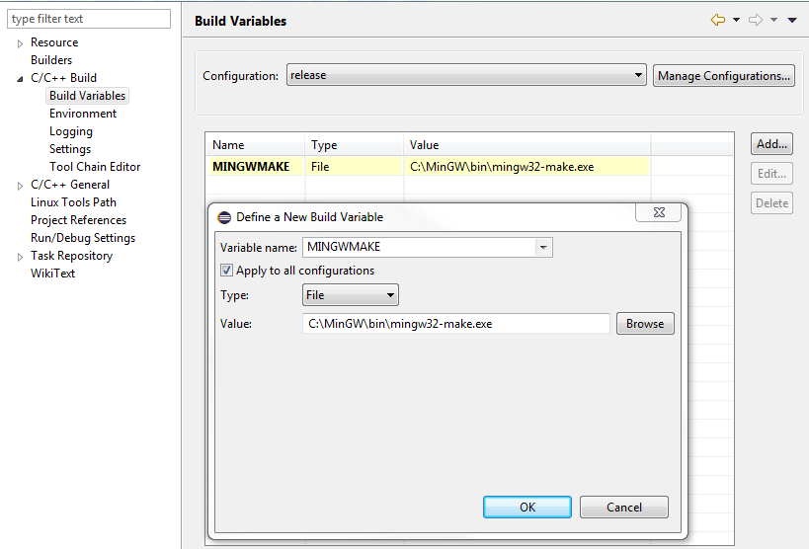

1. **C/C++ build configuration:**

Go to project-> properties (make sure that the newly imported project is selected at the project explorer) or on the project explorer, select project right click -> properties

Select C/C++ Build. Uncheck use default build command.

Replace build command with the MinGW make and file name (please use Build/default Variables). The Location of Makefile (located at the source dir)

**Build Command**: ${MINGWMAKE} -f ${workspace_loc:/${ProjName}}/Makefile

**Build Directory:** ${workspace_loc:/ ${ProjName}}/release/

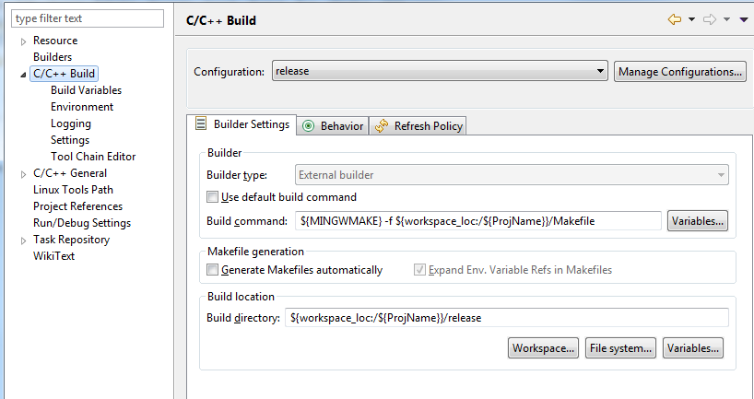

1. **Setup includes** (This is only optional. for indexing of eclipse.)

* Add location of BCP includes (<work dir>/BCP32)
* Add location of SQLITE3 includes (<work dir>/SQLITE) (optional)

On Project properties ->C/C++ general collapse -> Paths and Symbols

On the “includes” GNU C++ tab. Select add.

Check “add to all configuration”.

Use variable to specify location.

Directory: ${workspace_loc:/${ProjName}}/BCP32/include

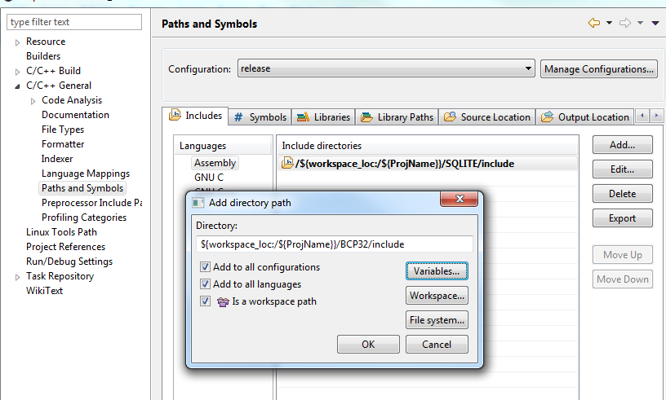

Do the same procedure for SQLITE but use SQLITE folder name or location (optional)

1. **Setup library paths:** (Optional)

On the library Paths tab.

**Check:**”add to all configuration” and “add to all languages”

**Directory:** /${workspace_loc:/${ProjName}}/BCP32/lib

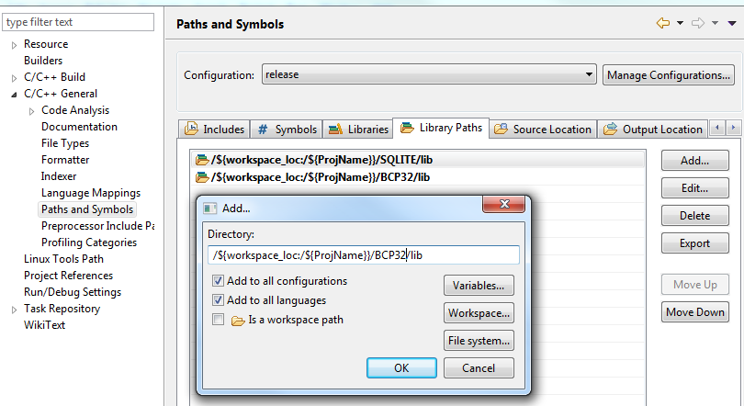

Wait for the indexer at the lower right corner to finish. 

1. **Configure Makefile**
2. Make sure that the Makefile is in the project directory and it is the latest one. The original Makefile has been altered to cater BCP in Cygwin environment.

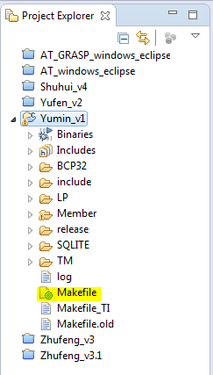

1. Open Makefile and modify:

Working Directory: Contains all external includes and library location. Can contain optional libraries.

**CURDIR** -> current directory Contains the absolute path of the BCP library

**BCPdir** -> Location of BCP libraries inside current directory

**PROJDIR** -> Contains the project directory

**BIN**-> Contains Binary creation directory

**EXE**-> executable name

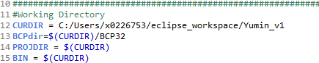



1. **Build the Project**
2. Copy cygwin1.dll, cygstdc++-6.dll,cygquadmath-0.dll, cyggfortran-3.dll, cyggcc_s-1.dll,cyglapack-0.dll, cygblas-0.dll, cyggccpp-1.dll from Cygwin Directory
3. Create a run external batch file.

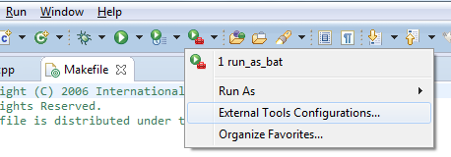

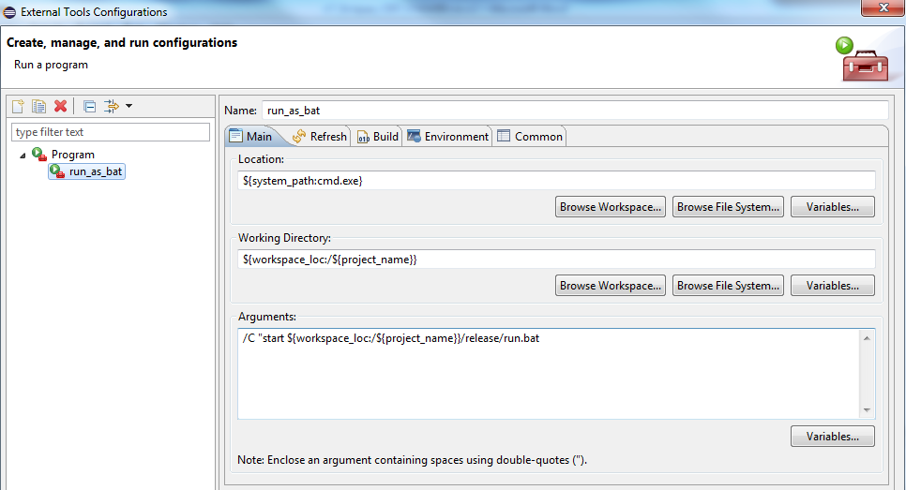

**Name**: <name of the batch file>

**Location**: ${system_path:cmd.exe}

**Working Directory**: ${workspace_loc:/${project_name}}/release

**Arguments**: /C "start ${workspace_loc:/${project_name}}/release/run.bat

Note: there is a bug in the BCP library that does not allow to run under different working directory except than the current exe file location. “/release” is the build location specified in the C/C++ build options.

1. Modify Batch file

Batch file must be located at build location. eg. “/release”

Change line 6 to executable name indicated at Makefile

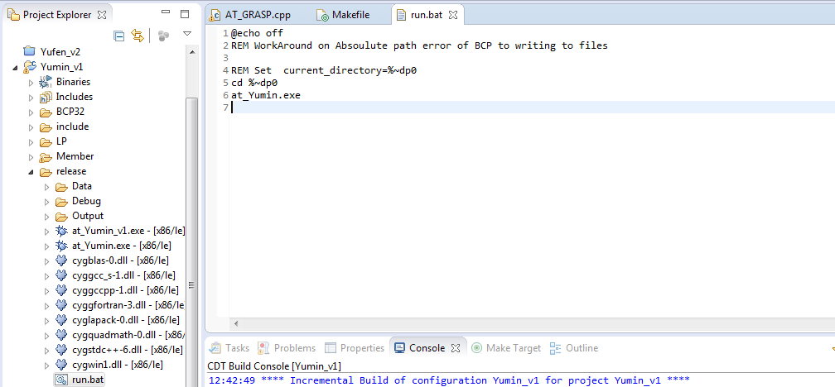

1. Running the program using the batch file

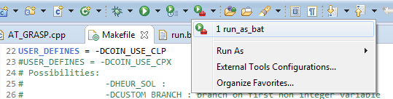

A new window will popup if no errors where encountered during compile

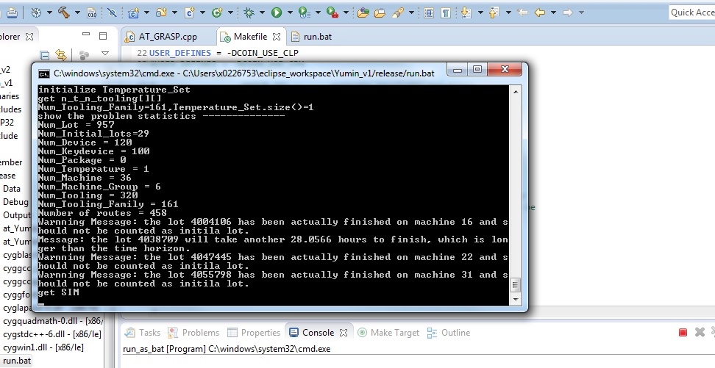

1. Errors that may be encountered:

errors:

*** Multiple target. Stop

Cause: GNU Make 3.8.1 does not handle windows path like 'C:\'

Solution 1: download the fix http://www.filewatcher.com/m/make-3.80-1.tar.bz2.286814-0.html

Select make-3.80-1.tar.bz2

Solution 2: to fix it: Note. please create a backup of make.exe of cygwin

you need make 3.80-1 or older and this needs cygintl-2.dll. download make3.80-1 from

http://www.filewatcher.com/m/make-3.80-1.tar.bz2.286814-0.html

and the needed Dll from

http://www.dllguru.com/cygintl-2.dll.html extract it somewhere

rename your make in cygwin/bin to makeVersion e.g. make3.82.90

copy cygintl-2.dll and make into cygwin/bin

try build your project in eclipse twice, the problem should be disappeared

solution 3: install mingw

copy make file from <mingw directory>/bin/make.exe to <cygwin directory>/bin

solution 4: best: Point to mingw make.exe

on project properties->c/c++ Build.

uncheck use default build command.

locate make file (eg. c:\mingw\bin\mingw32-make.exe)